Aimee Valladares

U0000007023

Computer Science, Software Engineering

CEN 4722

# Assignment 4

### **Introduction**

The mobile application, Filmation, serves as a hub for information regarding new movies that are released on multiple platforms. In other words, the mobile application serves as a one-stop shop for new releases of movies that are available in theatres or on streaming services. The interface will include a home screen that appears when the app is first open. The interface will include a menu screen that includes several options for the app and lead to other interfaces like the location screen or movie info screen.

### **Screens**

The *opening screen* is the first screen the user sees when they open up and use the application. This screen is meant to allow the user to transition between the *home screen*, *location screen*, and the *contact screen*.

The *home screen* is one of the screens that the user can access and typically serves as the main screen since it is the page that contains most of the information about films and new releases. The user can transition from this screen by interacting with the menu button and going to the *menu screen*. However, pressing the logo at the top-left corner in other screens allows the user to transition back to this page.

 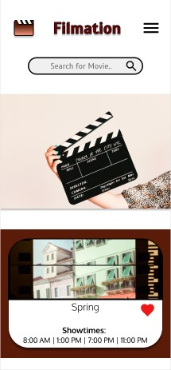

**Figure 1: Opening Screen Figure 2: Home Screen**

The *menu screen* primarily consists of the buttons that allows the user to navigate throughout the application as it contains several buttons that lead to other screens. To transition into this screen, the user must press the *menu icon* on the top-right corner. To transition to the other screens, the user must press the corresponding button. For instance…

* To transition to the *profile screen* the user must press the *Profile button.*
* To transition to the *favorite screen* the user must press the *Favorite Movie button.*
* To transition to the *location screen* the user must press the *Locate Theatre button.*
* To transition to the *contact screen* the user must press the *Contact Info button.*
* To transition to the *settings screen* the user must press the *Setting button.*

The *location screen* is the screen that allows the user to find and set a movie theatre based on their location by inputting a ZIP code. This screen also allows the user to find other theatres in their area (based on their ZIP code). The user can transition to this screen in 2 ways:

1. Pressing the *Locate Theatre button* in the *menu screen.*
2. Pressing the *Find Movie button* in the *opening screen*.

There are 2 ways that the user could transfer out of this screen.

1. Pressing the logo at the top-left corner, to go back to the *home screen*.
2. Pressing the menu icon at the top-right corner, to go to the *menu screen*.

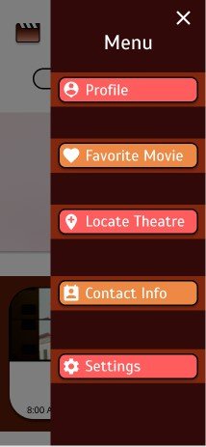 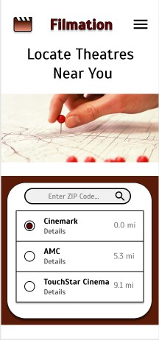

**Figure 3: Menu Screen Figure 4: Location Screen**

The *contact screen* is the screen that contains all of the contact information to the company of the app for the user to see. To transition into this screen, the user can:

1. Pressing the *Contact Info button* in the *menu screen.*
2. Pressing the *Contact Us button* in the *opening screen*.

To transition out of this screen, the user can:

1. Pressing the logo at the top-left corner, to go back to the *home screen*.
2. Pressing the menu icon at the top-right corner, to go to the *menu screen*.

The *profile screen* is the screen that allows the user to enter their personal information and customize their profile. The *Change Profile button* leads back to the profile screen as it is meant to update the profile screen by saving the new information inputted by the user. The only way to transition to this screen is by pressing the *Profile button* on the *menu screen*. To transition out of this screen, the user can:

1. Pressing the logo at the top-left corner, to go back to the *home screen*.
2. Pressing the menu icon at the top-right corner, to go to the *menu screen*.

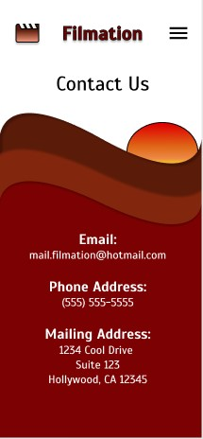 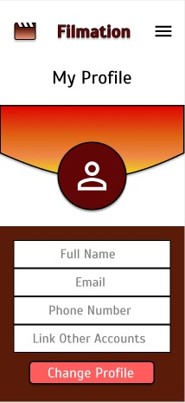

**Figure 5: Contact Screen Figure 6: Profile Screen**

The *favorite screen* is the screen that contains all of the movies the user has liked by clicking on the *Favorite icon* in the card view. The only way to transition into this screen is by clicking the *Favorite Movie button* in the *menu screen.* To transition out of this screen, the user can:

1. Pressing the logo at the top-left corner, to go back to the *home screen*.
2. Pressing the menu icon at the top-right corner, to go to the *menu screen*.

The *settings screen* is the screen that allows the user to change and customize certain aspects of the overall application for their device like changing notification or privacy settings. The *Change Settings button* leads back to the *settings screen* as it is meant to update the settings screen by saving the new information inputted by the user. The only way to transition into this screen is by clicking the *Settings button* on the *menu screen*. To transition out of this, the user can:

1. Pressing the logo at the top-left corner, to go back to the *home screen*.
2. Pressing the menu icon at the top-right corner, to go to the *menu screen*.

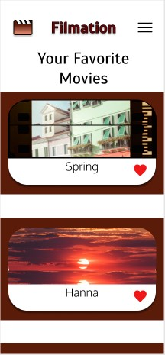 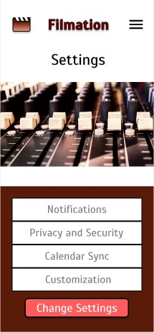

**Figure 7: Favorite Screen Figure 8: Settings Screen**

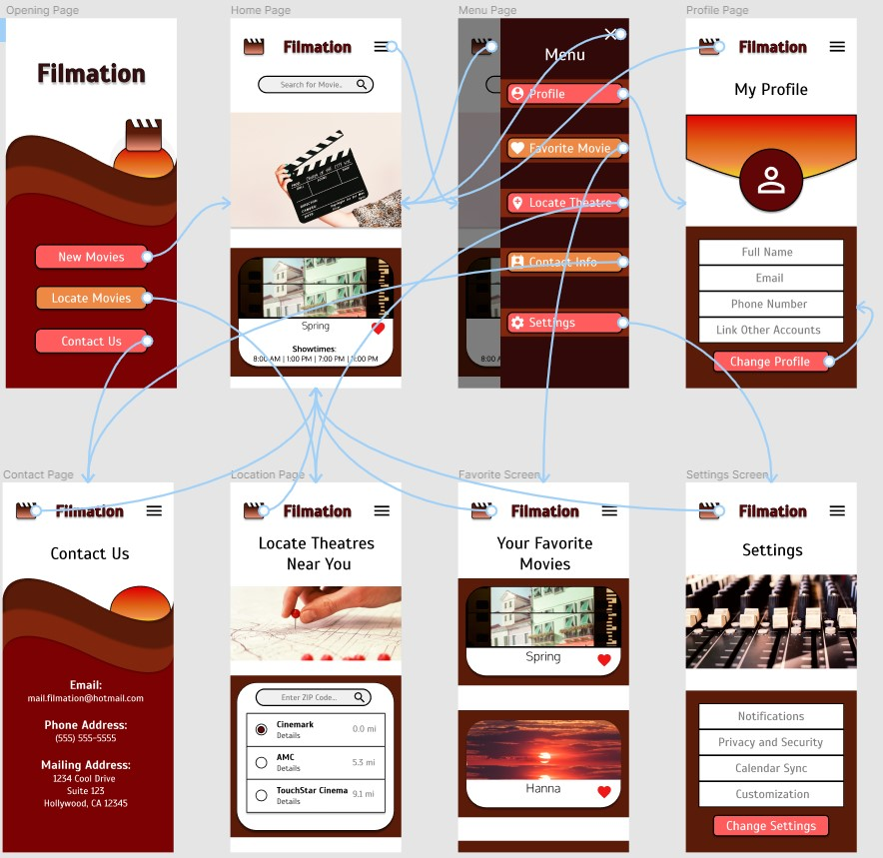

**Figure 9: Overall Transitions Across the Interface**

### **Colors, Icon, and Button Choice**

The colors I chose to use were meant to help illustrate a sense of happiness, grandeur, and comfort going to the movie theatre can bring. The colors I used are meant to bring excitement without it being distracting or annoying as users prefer slightly darker colors and pastel shades. I primarily used 3 different colors to avoid the interface from being cluttered or inconsistent. For the user interface, red is used to help express passion, excitement, and energy. A darker shade of red is typically used as a background color while a pastel shade is used to emphasize buttons. Brown is used to express comfort, reliability, and simplicity. The darker shade of brown is used throughout the user interface as a background to help illustrate depth. Meanwhile, for the app logo the darker shade and pastel shade as a gradient to help emphasize the icon. Finally, orange is used to express warmth, enthusiasm, happiness, and friendliness. The orange color is used as primarily a highlight for certain screens meanwhile a pastel shade is used to emphasize buttons.



**Figure 10: Color Palette for the Interface**

The icons I chose to use are primarily for the menu and helped emphasize the function each button is meant to do. The icons I used have a simplistic, easy-to-understand, readable design. Specific icons I used like the *Favorite* icon or *Hamburger* icon are more universally recognized due to current convention and standards. Moreover, the icons I chose would have similar context to other well known and used apps. For example, the *Location* icon looks similar to the icon used for Google Maps and has very similar context since they both imply finding a new location. With the icons used consistently throughout the user interface, it allows the user to recognize the button and navigate through the app more easily.



**Figure 11: Location Icon Comparison with Google**

Throughout the user interface I used 10 icons. The first icon is the *movie icon* and this icon serves as the logo for the mobile app and a home button that allows the user to go back to the home screen from any other screen except for the opening screen. The second icon is the *menu icon* and it allows the user to pull up the menu and transition to the menu screen. The third icon is the *search icon* and it is meant to serve as a button that allows the user to search any input they enter into the search bar. The fourth icon is the *favorite icon* which serves as a button that favorites or unfavorites a movie, this allows the user to change what movies appear in the user’s favorite movie list to the favorite screen. The fifth icon is the *close icon* and it is meant to transition out of the menu screen and to the previous screen.

The sixth icon is the *person_pin icon* which is used to help indicate that the profile button leads to the profile screen and make the button more recognizable. The seventh icon is the *add_location icon* which is used to indicate that the locate button leads to the location screen and makes the button more recognizable. The eighth icon is the *perm_contact_calendar* *icon* which is used to help indicate that the contact button in the menu screen transitions to the contact page and help make the button more recognizable. The ninth icon is the *settings icon* which is used to help indicate that the settings button leads to the settings screen and helps make the button more recognizable. Finally, the tenth icon is the *person_outline icon* which is used as the default image for the profile image in the image screen. The user should be able to click on the icon and the app will prompt the user to upload a new image for the profile.



**Figure 12: The Icons Used Throughout the Interface (Default)**

The user interface contains a total of 10 buttons though the buttons can do 8 functions. The buttons alternate between a pastel red color and a pastel orange shade. These colors are used to highlight the buttons without it being distracting. The *New Movies button* is used to transition to the home screen that is the overview and main source of information for the user.

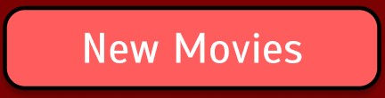

**Figure 13: New Movies Button**

The *Locate Movies* and *Locate Theatre buttons* both serve the same function as allowing the user to transition into the location screen that lets them locate theatres near them.

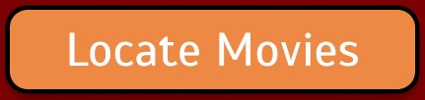

**Figure 14: Locate Movies and Locate Theatre Buttons**

The *Contact Us* and *Contact Info buttons* both serve the same function that allows the user to go to the contact screen which has the contact information for the app developers.

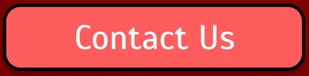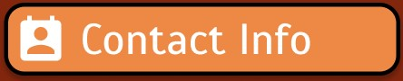

**Figure 15: Contact Us and Contact Info Buttons**

The *Profile button* is used to transition to the profile screen that contains the personal information for the user. In the profile screen, the *Change Profile button* can be seen and it is meant to update the profile screen with new information that the user has entered.

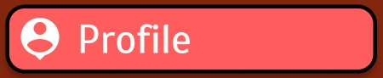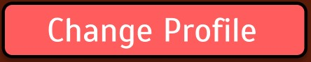

**Figure 16: Profile and Change Profile button**

The *Favorite Movie button* is used to transition to the favorite screen which contains a list of all the user’s favorite movies since they pressed the favorite icon.



**Figure 16: Favorite Movie Button**

Finally, the *Settings button* is used to transition to the settings screen which allows the user to customize certain application settings. In the settings screen, the *Change Settings button* can be seen and it is meant to update the settings screen with new information that the user has entered. Additionally, the changes should be seen in the application, other related applications, and the device. For instance, if the notification settings are changed then that should be reflected on the device when the notifications occur.



**Figure 17: Settings Button**

### **Menu Design**

The menu design is that when the user presses the *Hamburger* icon, then a pop-up box will appear. The menu box contains all of the menu buttons that contain icons so that they are more recognizable. The spacing between buttons is meant to be consistent. The wording for the menu is meant to be direct, concise, and unambiguous. Finally, the order is meant to reflect the frequency of use. For instance, the more frequently viewed or used buttons are at the top like *Profile* while the least used buttons at the bottom like *Setting*. Finally, to highlight the menu, the previous page in which the menu icon is pressed is visually grayed out.

### **Mobile App Design Guidelines**

To help alleviate the long-scroll problem, the application utilizes cards to help break up the information. To follow the font type and size design guidelines, I followed guidelines regarding the typeface, font-size, and color contrast. The typefaces utilized for the application are Scada () and Oxygen (), which both work well in multiple sizes and weights so it is still readable and usable. The font size throughout the application changes but the smallest font size used is 20 points, so that users can read it without the need to zoom. Finally, to prevent color issues between font and background I tried following the 60-30-10 rule with brown being 60%, red being 30%, and orange being 10%.

To ensure that the user interface allows for enough spacing and padding, I tried following several spacing and padding guidelines. First, to make sure there is enough spacing and improve legibility, the paragraph spacing used throughout the application is 1.15. Moreover, the text and other elements like images and icons do not overlap. Additionally, I tried limiting the amount of white space since it is more of an active element. Finally, I tried limiting the number of icons, images, and text to make sure the interface is not cluttered. For instance, a screen can have a maximum of 3 different icons and one fixed image like in the *home screen*.

Moreover, when designing the interface I tried following finger-friendly guidelines to make sure it is user-friendly. For instance, none of the controls measure less than 40px as the buttons sizes (Width ✕ Height) are either:

* 291px ✕ 54px
* 280px ✕ 60px

The icon sizes are either:

* 90px ✕ 80px
* 50px ✕ 40px
* 50px ✕ 50px
* 40px ✕ 40px

I followed certain guidelines about keeping tab bars clear and clean that were applicable since the user interface I designed does not use tabs. For instance, I tried to make sure that I used readable and recognizable icons so the user can understand them. Additionally, most of the icons are accompanied by button labels to help clarify what they represent. However, I felt tabs were not in the best interest of the user interface design since the application has over 5 navigation options. Moreover, I felt that with the limited space of a navigation bar it may not be as clear to what each tab does.

For the user interface, I made sure that the search box followed design guidelines since it is a key function of the app and must be readily seen by the user. I have the search box with the search (magnifying glass) icon displayed at the top of the screen.

Finally, I tried displaying and emphasizing content by using cards to help naturally display actionable content.

### **Response Time and Error Handling**

The ideal response time for the transition and fully loaded screen is to be 200-300 ms as the instant response does not have the user wait for content. Moreover, if the application is experiencing issues, then within 1-3 seconds the application will load the skeleton screen. If the error is greatly affecting the application response time, show an error screen that explains what the error is by providing feedback. Additionally, for error handling the application will allow the user to go back to the previous screen so there is a clear, easy way out of each state.

To enhance the UX for response time I try to keep the response time less than 3 seconds as any more time may cause frustration and a loss of interest in the app. To help the app appear more quickly and respond, the skeleton screens are used. For instance, the user may experience bad internet connection and signal due to the application being used at different locations. As a result, the app response time may increase so using skeleton screens while information gradually loads will help with the appearance of speed.This will help the user understand progress while not immediately signalling the user to wait by adding anticipation.

Some errors that I anticipate are related to the text boxes that require user input. Specifically, in the *profile screen* the text boxes will need the correct format and appropriate values. For example, in the *profile screen* the email text box must have an appropriate and valid email. If the user tries to enter “[mail.123@gmail.com](mailto:mail.123@gmail.com)” then the text box will not give an error indicator. However, if the user tries to enter “mail.123gmail.com” then the text box will give an error indicator illustrating that the email entered is not the correct format. The error messages will operate similarly to figure 18.

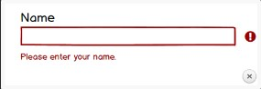

**Figure 18: Error Handling Example for Text Boxes**

Additionally, for the *Change Profile* and *Change Settings* an error that might occur that does not allow the user to update the information once these buttons are pressed. This error can occur if there is bad internet connection. To handle this error, the application will display a pop-up error message at the bottom of the screen explaining the issue to the user while also offering a way to fix the issue. The error messages will operate similarly to figure 19.

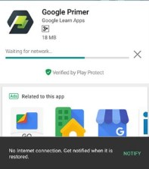

**Figure 19: Error Handling Example for Changing Information**